Part A: Multiple-Choice (K/U 1 mark each)

- Which of the following compounds has the lowest boiling point?
(a) hexane
(b) pentane
(c) 2, 2-dimethylpropane
(d) 2-methylbutane

- Consider the following structure of a compound:
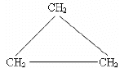
The compound is an isomer of
(a) propane
(b) propene
(c) propyne
(d) cyclopropene

- Why does the boiling point of an alkane increase as its chain length increases?
(a) The strength of London Dispersion force increases with increasing molecular size.
(b) There is more hydrogen bonding.
(c) The molecules are highly branched.
(d) None of the above.

- How many quantum numbers are necessary to designate the ‘location’ of a particular electron in an atom?
(a) 4
(b) 3
(c) 2
(d) 1

- In general, the atomic radius of elements generally increases down a group because
(a) effective nuclear charge increases
(b) effective nuclear charge decreases
(c) the magnetic quantum number increases
(d) both a) & c) are correct

- Which of the following compound has a dipole moment?
(a) CH₃CH₂CH₃
(b) CCl₄
(c) CO₂
(d) HCN
- Consider the following reaction A_{(aq) +} B_{(aq)} + heat C_{(aq)} + D_{(g)} carried out under SATP condition. When the reaction is complete, you measured the solution at 15⁰C and pressure at 1.5atm. What does this tell you about the nature of the system?
(a) open system
(b) closed system
(c) isolated system
(d) impossible to occur

- Chemical equilibrium occurs when
(a) opposing forces balance
(b) opposing forces are unbalanced
(c) the forward and reverse reactions occur at different rates
(d) the forward and reverse reactions are unbalanced

- Which of the following is NOT a method you can use to speed up the rate of reaction?
(a) increase the pressure by adding Ar (g)
(b) add catalyst to the reaction mixture
(c) heat up the reaction by raising the temperature
(d) increase the concentration of both reactants

- Which of the following is NOT an effective way to measure the rate of reaction:
2A_{(aq)} + B_{(aq)} C_{(aq)} + D_{(g)} + 2H₃O⁺_{(aq)} + 10kJ?
(a) measuring the volume of gas generated
(b) measuring the pH change of reaction
(c) measuring the temperate change of the reaction
(d) none of the above

- Consider the reaction: A_{(g)} + B_{(g)} ⇌ 3D_{(g)} ∆H=3.2kJ/mol, which of the following would cause the equilibrium to shift to the left?
(a) increase the pressure of the system by decreasing volume
(b) decrease the temperature of reaction
(c) all of the above
(d) none of the above

- Which of the following is NOT a process to prevent corrosion?
(a) galvanizing
(b) sacrificial anode
(c) cathodic protection
(d) all of the above are corrosion prevention processes

- What is an electrolytic cell?
(a) another name for any spontaneous cell
(b) another name for a galvanic cell
(c) a cell that uses an external energy source to drive a non-spontaneous redox reaction
(d) a cell that uses an internal energy source to drive a non-spontaneous redox reaction

- When water is electrolyzed, what is the hydrogen gas to oxygen gas ration in the process?
(a) 1 : 1
(b) 1: 2
(c) 2 : 1
(d) 2 : 3

- What is the correct standard cell notation for a zinc-copper cell?
(a) Zn_{(s)} | Zn²⁺_{(aq)} || Cu²⁺_{(aq)} | Cu_{(s)}
(b) Cu²⁺_{(aq)} | Cu_{(s)} || Zn_{(s)} | Zn²⁺_{(aq)}
(c) Cu_{(s)} | Cu²⁺_{(aq)} || Zn_{(s)} | Zn²⁺_{(aq)}
(d) Cu_{(s)} | Cu²⁺_{(aq)} || Zn²⁺_{(aq)} | Zn_{(s)}

Part B: Short Answer

- 3-methylbutan-2-ol can be used as common organic solvent, food additive, or as an intermediate in the manufacture of other chemicals. Answer the following questions regarding this compound. (C3, T3, A3)
- Draw the structural formula for 3-methylbutan-2-ol.
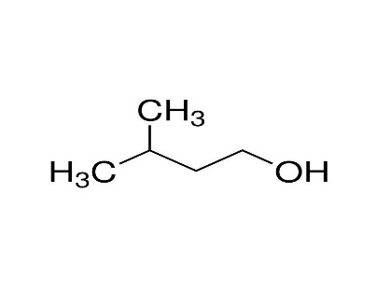
- Use skeletal formula to represent the dehydration reaction when using 3-methylbutan-2-ol as a reactant.
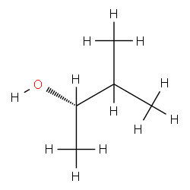
- Use skeletal formula to represent the product if you mix 3-methylbutan-2-ol with HCl
. 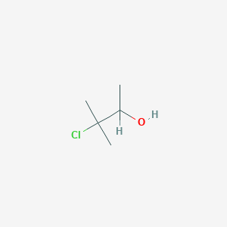
- Use skeletal formula to show how you can synthesize an ester from 3-methylbutan-2-ol. What is the name of this reaction?

- 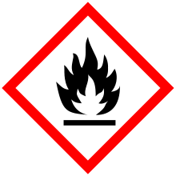You find this symbol on the container of the alcohol, what does this indicate?

Means alcohol is flammable.

- Draw the electron configuration and orbital-filling (energy level) diagram for Bromine. (C1, T3)

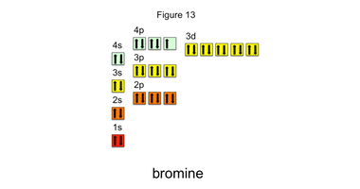

- Use a 3D orbital diagram to show the bonding orbitals and geometry of formaldehyde (methanal). Be sure to indicate the hybridization and type of bonding for each orbital and bond. Also indicate the polarity of the molecule using arrow(s). (C2, A3)

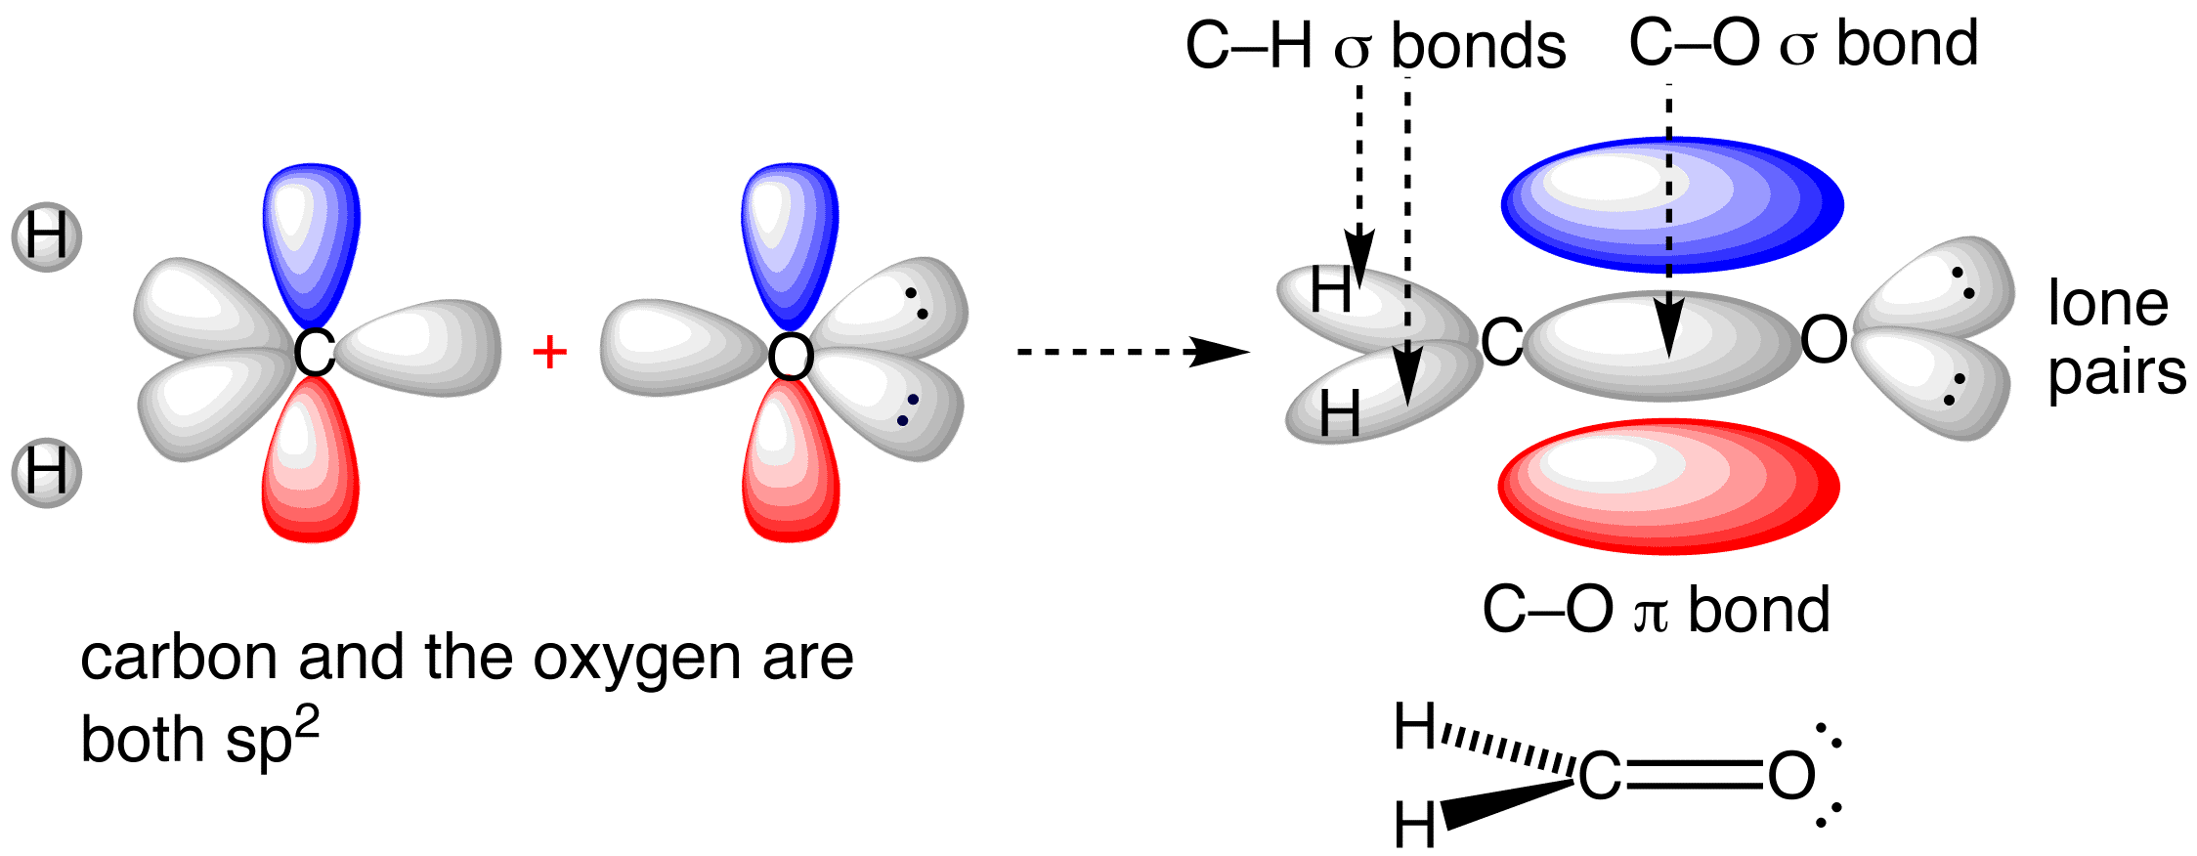
- On burning CH₃OH, carbon dioxide and water are obtained as final products. Chemical reaction for combustion of CH₃OH is given below:
CH₃OH (l) + 3/2O₂ (g) CO₂ (g) + H₂O (l)
Enthalpy of formation for CH₃OH; CO_{2;} and water is –239 kJ/mol, –393.51 kJ/mol; and –285.83 kJ/mol, respectively. (C3, T3)
- Estimate the ∆H⁰_{comb} for the reaction.
-(-239)+(-393)+2(-285.83)= -725.66kJ/mol
- Draw an enthalpy change diagram for this reaction, label all reactants and products, as well as the enthalpy change.

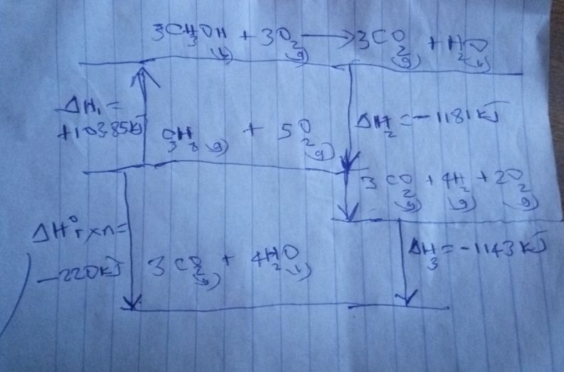

- Draw a Gibbs free energy diagram for this reaction, label the activation energy, and activated complex (assume in this case ∆G = ∆H).

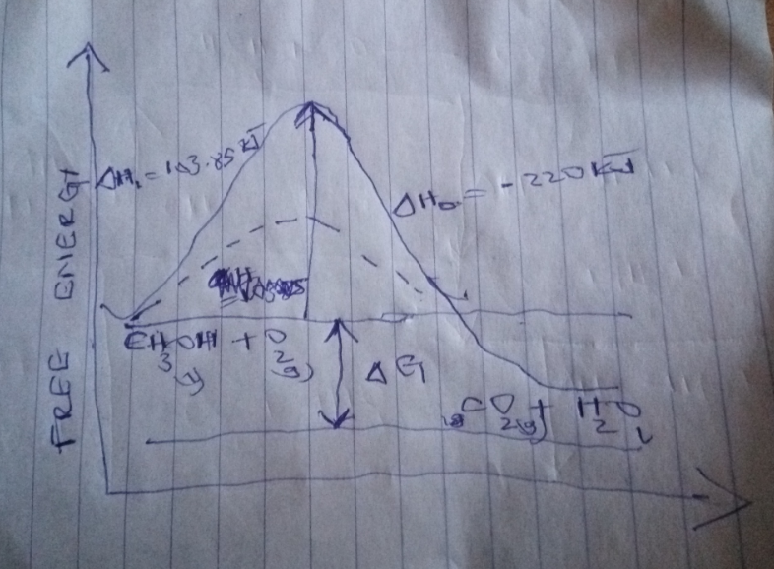

- 5.00 g of sodium hydroxide is dissolved in 150 mL of water. Using a coffee-cup calorimeter, the temperature change of the water is measured to be 2.2C. The specific heat capacity of water is 4.184 J/g⁰C. Determine the heat released per gram of sodium hydroxide dissolved. (A2)
Mass of water = 150cm³ X1g/cm³=150g
Heat change= mass X heat capacity X change in temperature
= 150X4.184X2,2
= 627.6J
Heat realeased per gramme=627.6/5=125,52J/g

- Consider the reaction: 2NO(g) + Br₂(g) 2NOBr (g). A student performs three experiments studying initial concentrations and initial rates. The data is summarized in the table below. (C1, A3)
- Determine the rate law equation for this reaction and the rate constant k. Be sure to include the correct unit for k.
Rate law equation =k[Br₂]²
K=1.4 x10⁻¹/(0.6)²=3.8 X 10⁻¹[Br₂/]s⁻¹

- Base on your rate law equation, does this reaction seem to be a one-step reaction, or multi-step reaction involving reaction intermediates.
Multi-step step involving a series of reactions.

[NO] | [Br₂] | Rate (mol/Ls)
0.80 | 0.60 | 1.4 x 10⁻¹
1.60 | 0.60 | 2.8 x 10⁻¹
0.80 | 1.20 | - x 10⁻¹

- Ammonia when dissolved in water is a weak base with K_{b} = 1.8 x 10⁻⁵, pKa = 9.24. You have 25mL of an ammonia solution of unknown concentration, answer the following questions. (C3, T3, A3)
- Compute the concentration of NH₄⁺_{(aq)} when the solution is at equilibrium.

Concentration = Kb/pKa = 1.8 x 10⁻⁵/9.24= 1.948 x 10⁻⁶
- Would you use 0.1M HCl or 0.1M NaOH as titrant?
0.1M HCl since Ammonia solution is a base
- You added 25mL of the titrant to your unknown solution and reached the equivalence point, what is the concentration of your unknown ammonia solution?
= 0.1M x 1.948 x 10⁻⁶ = 1.948 x 10⁻⁷
- Compute the equivalence point and midpoint pH.
Equivalence point =pKa=9,24

= 9.24 x 0.1= 0.924
- Draw the titration curve for this experiment, label the pH for both the equivalence and half-equivalence points, and the volume at which these occur.
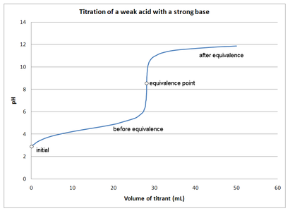

- d storage cell is invented by Gaston Plante in 1859, and is one of the most common type of battery used on cars today. The unbalanced reaction can be represented by the equation: (C2, T3, A1)
Pb_{(s)} + PbO_{2 (s)} + SO₄²⁻_{(aq)} PbSO_{4 (s)}
- Identify the anode and cathode half reactions.
Pb ( s) + SO2- 4 = PbSO4 ( S ) + 2e-(Anode)
PbO₂(s) + 4H+ 2e = PbSO₄ (s) + 2H₂O (Cathode)
- Use the standard reduction potential table provided to determine the cell potential.
E(reduction)-E(oxidation)
=0.83-(-1.25)=2.08V
- Balance this reaction under acidic conditions.
PbO₂+ Pb+ 2 H₂SO₄ 2PbSO₄ +2H₂O
- Use line notation to represent the cell reaction.

